Congratulations on choosing MBA Programs at Krakow School of Business. This user manual will guide you through the process of:
- Signing-up on IRK system,
- Choosing your desired MBA Program,
- Registering for the Program,
- Paying the recruitment fee.

Documents you will need for registering:
- Polish ID (dowód osobisty) or a passport,
- Image of your photo in ID format,
- Scanned copy of your higher education diploma.

Documents you will need further into the process:
- English language certificate (if you have one),
- Current CV,
- Cover letter (use the template),
- Application form for the MBA studies – in the case of financing or co-financing the studies by the employer or in the case of self-employment,
- 2 recommendation letters from your business partners/employer,
- Any additional documents and certifications.
- If you are applying for MBA KSB + Master program you will also need:
  - Instead of the 2 recommendation letters (pt 5.) you will need 3 Confidential Recommendation letters,
  - Additionally you have to supply the Application for Graduate Admission.

Registering in the IRK system (if you do not have an account yet):

- Go to https://irk.uek.krakow.pl/pl/auth/register/consent/ you can change the language in the top right corner of the site:
  - 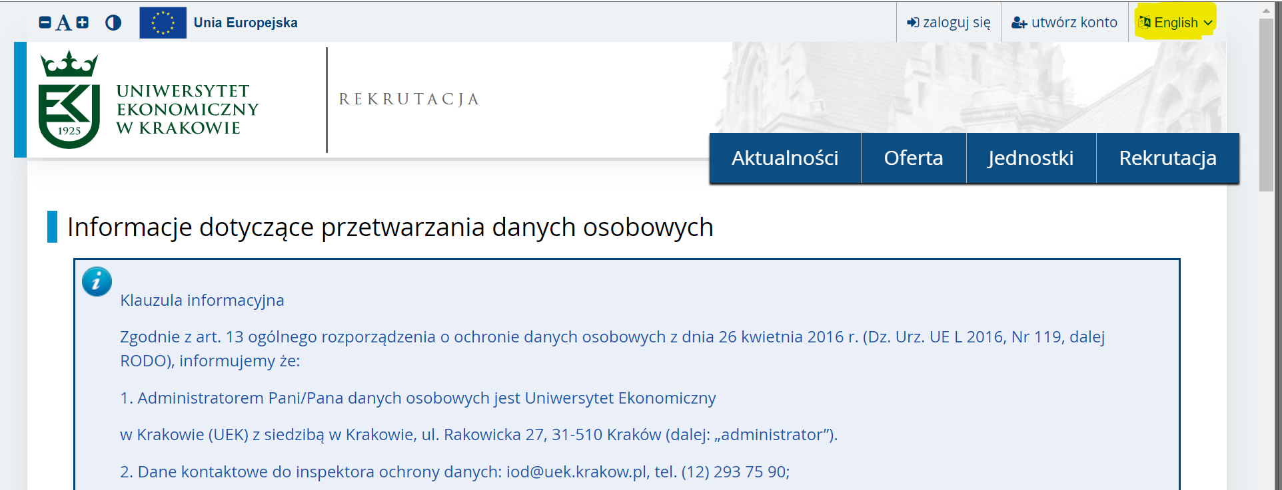
- Familiarize yourself with the personal data processing information, check the box below it and click “continue”,
  - 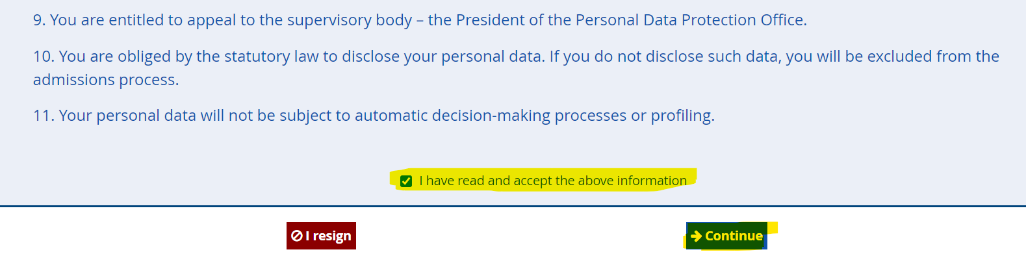

- Submit your e-mail and create a password and create your account:
  - 

- The system will now send an activation link to your address,
- Check your e-mail and click the activation link,
- Your account is now active and the system will now let you log in.
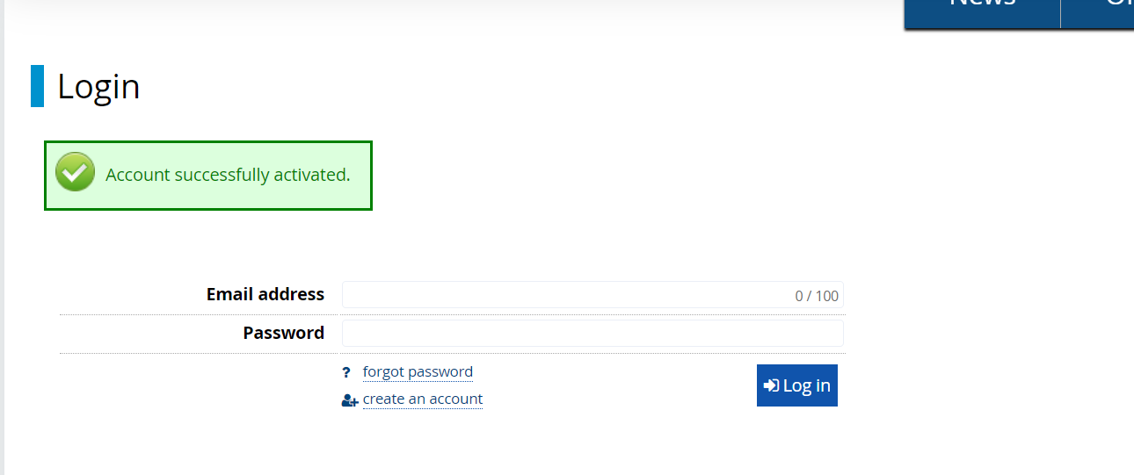

Filling out the „Personal forms” tab - 5 sub-tabs:
Before you choose a registration, “Personal forms” tab will contain “Basic personal data” only: | 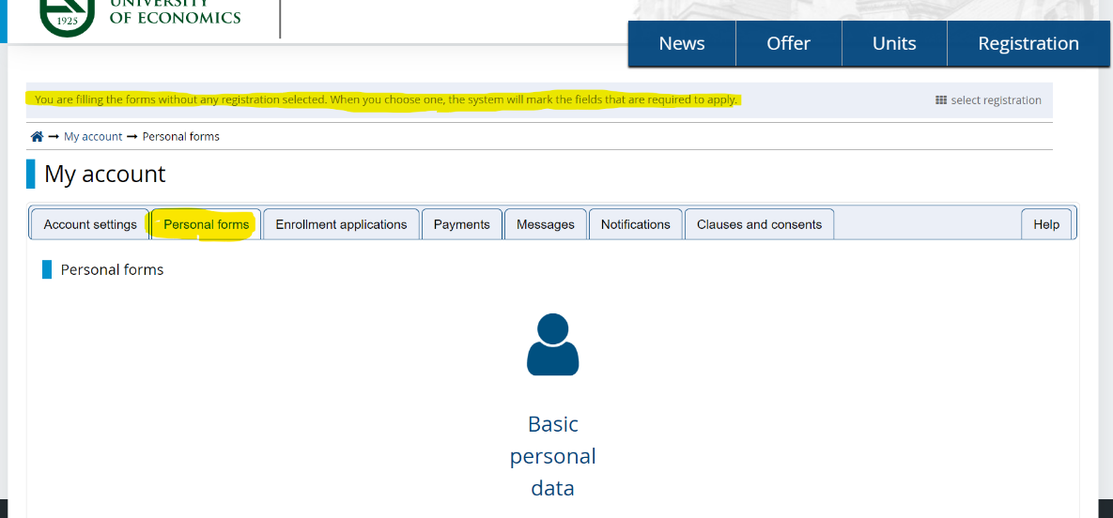
The system will mark all the fields that are required for you to apply. Go to the registration selection: | 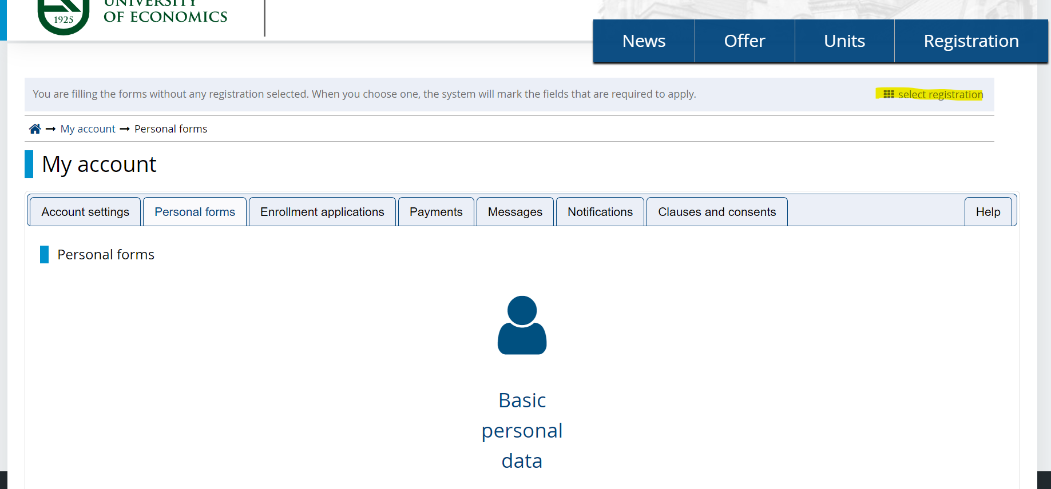
Find “Krakow School of Business KUE MBA Programs registration 23/24W” and click it: | 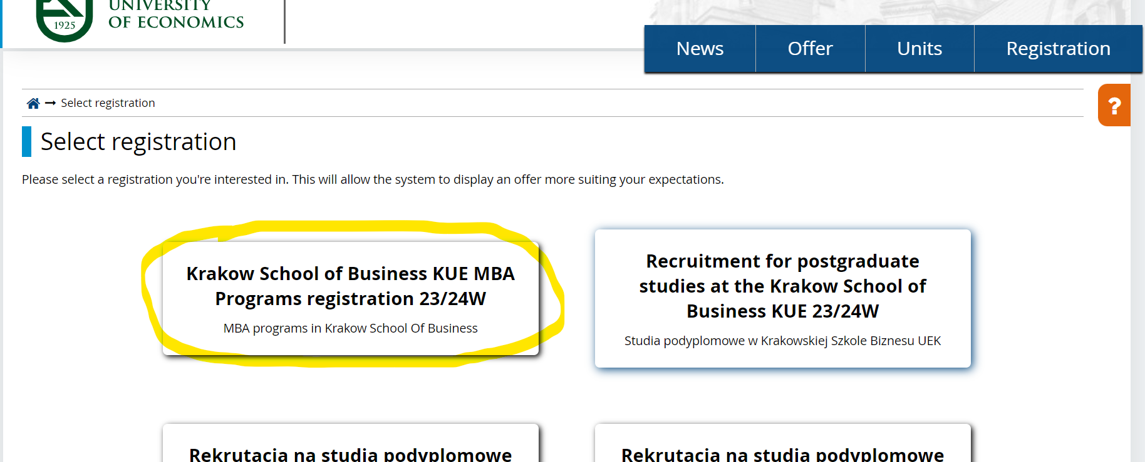
Additional sub-tabs will appear. Please fill out the information in all of them:  - Please make sure to include your country code in your phone number (in “+ _ _ “ format e.g. “+48”), | 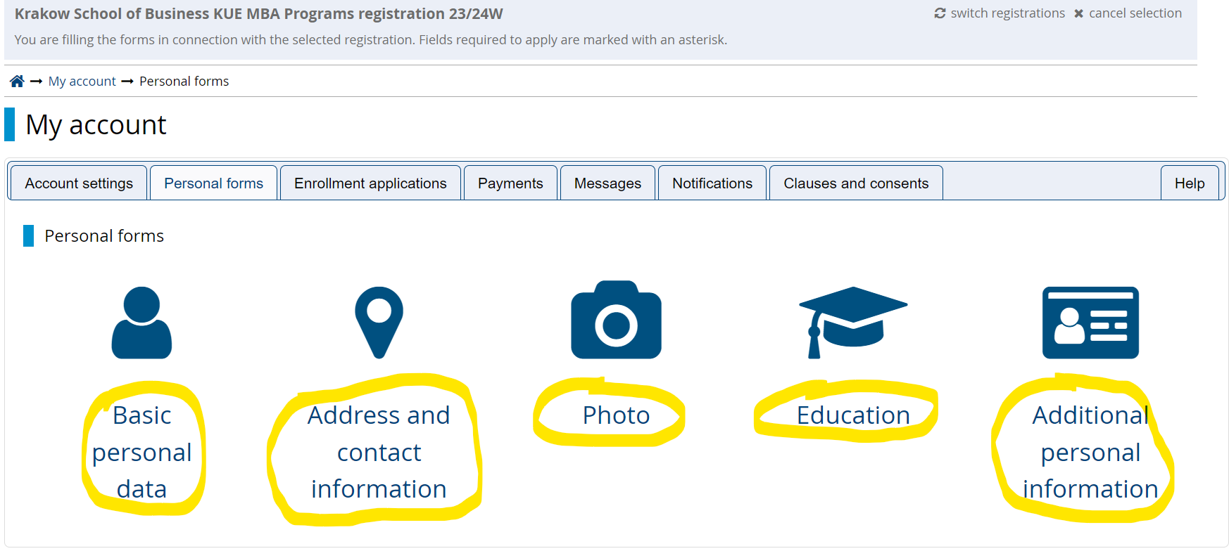
In the Education tab you will have to add your diploma details. Fill out the details and click “Save”: | 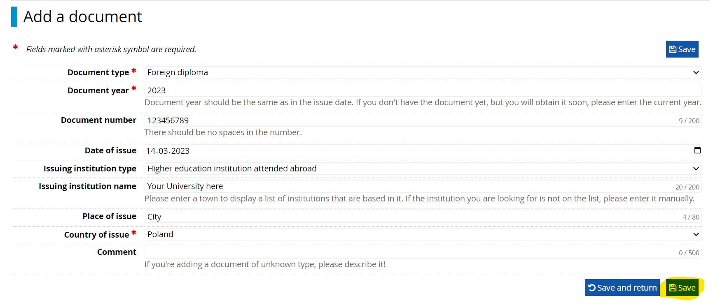
You will now have to upload a scan of the diploma. Upload the relevant file. | 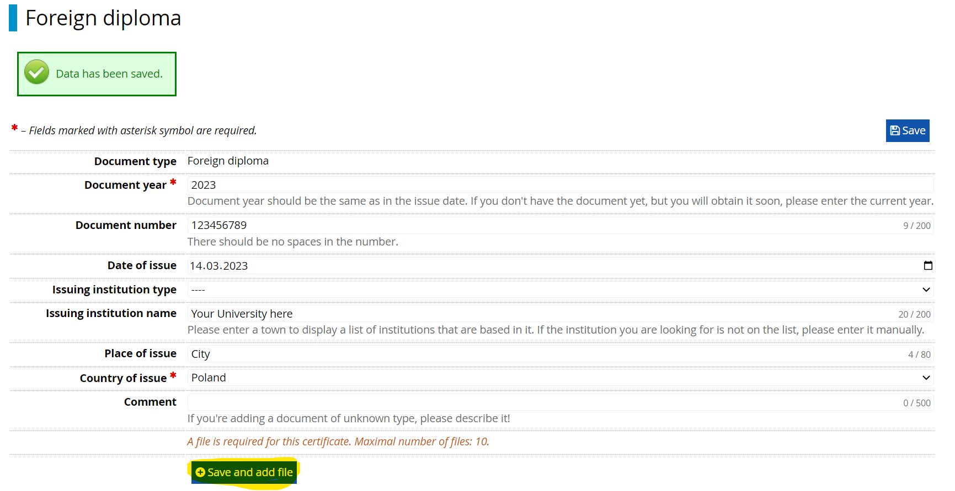

Choosing your program:
You can now choose an MBA program for which you want to register.
To choose the program go to the “Registration”: | 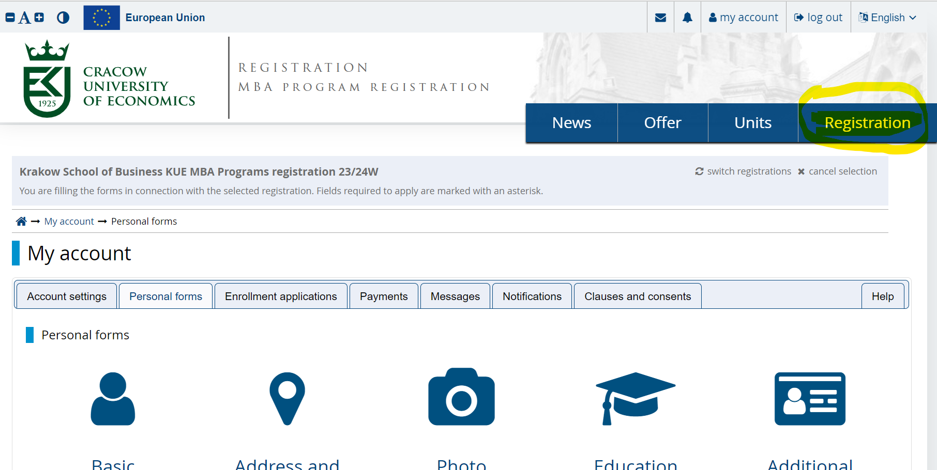
You will land on the registration page. Please read the information provided. You will find the general information about the Krakow School of Business MBA Programs, organization of classes, required documents, document templates etc. | 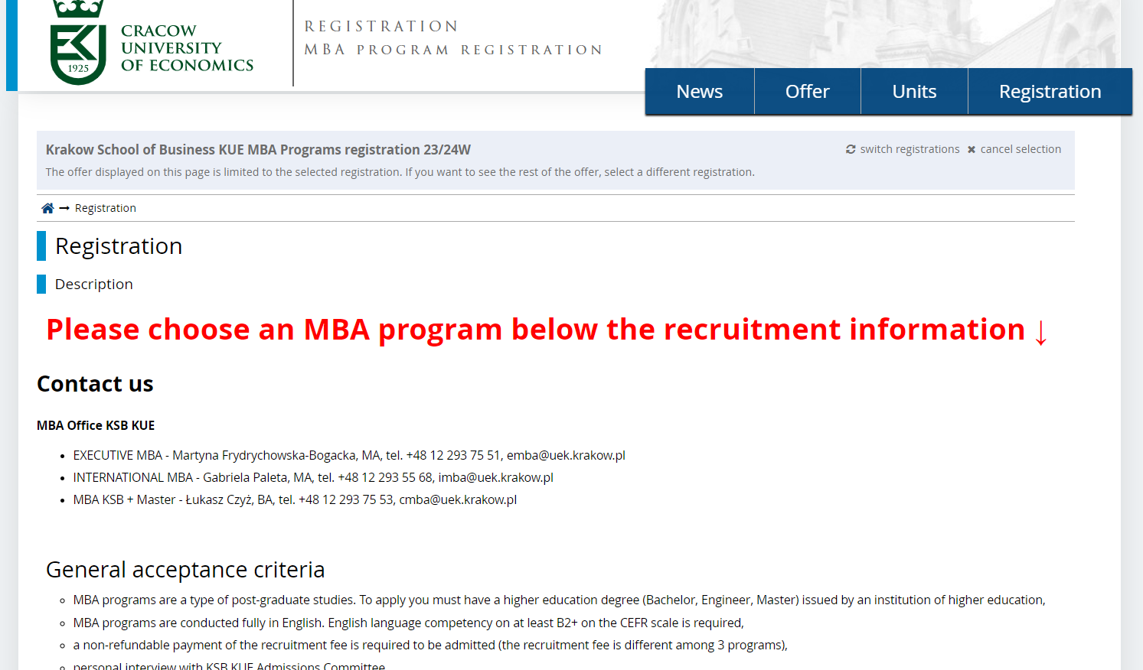
Choose the MBA Program on the bottom of the page: | 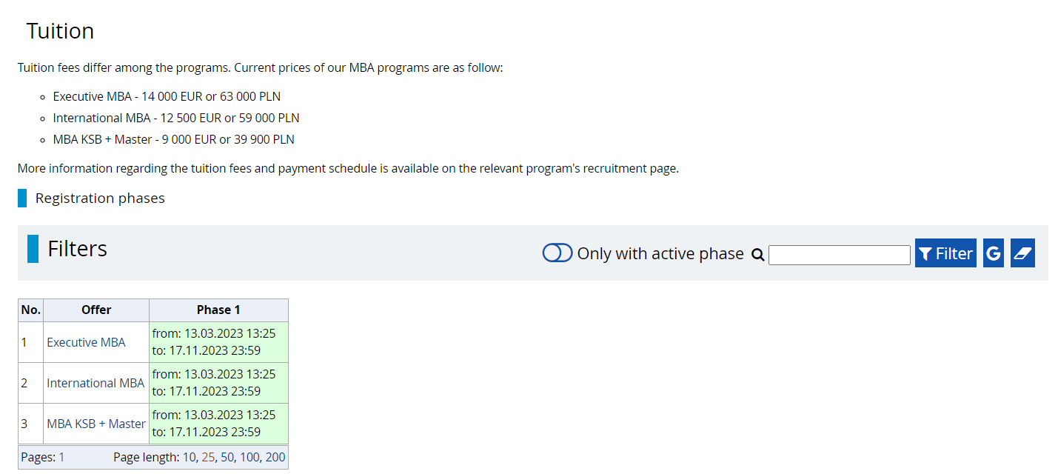
Read the chosen program’s description. Some of the MBA programs require additional documents. You can find the templates there. In the table you will find the program’s details and contact information.
To sign in click the sign in button:
Accept the “Personal data processing information” and consent to the processing of your personal data and then click “Continue”: | 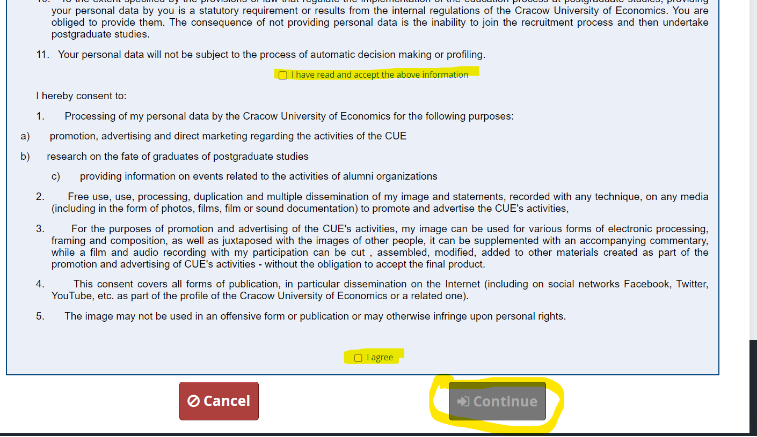
Select your diploma from the dropdown and click “Continue”: | 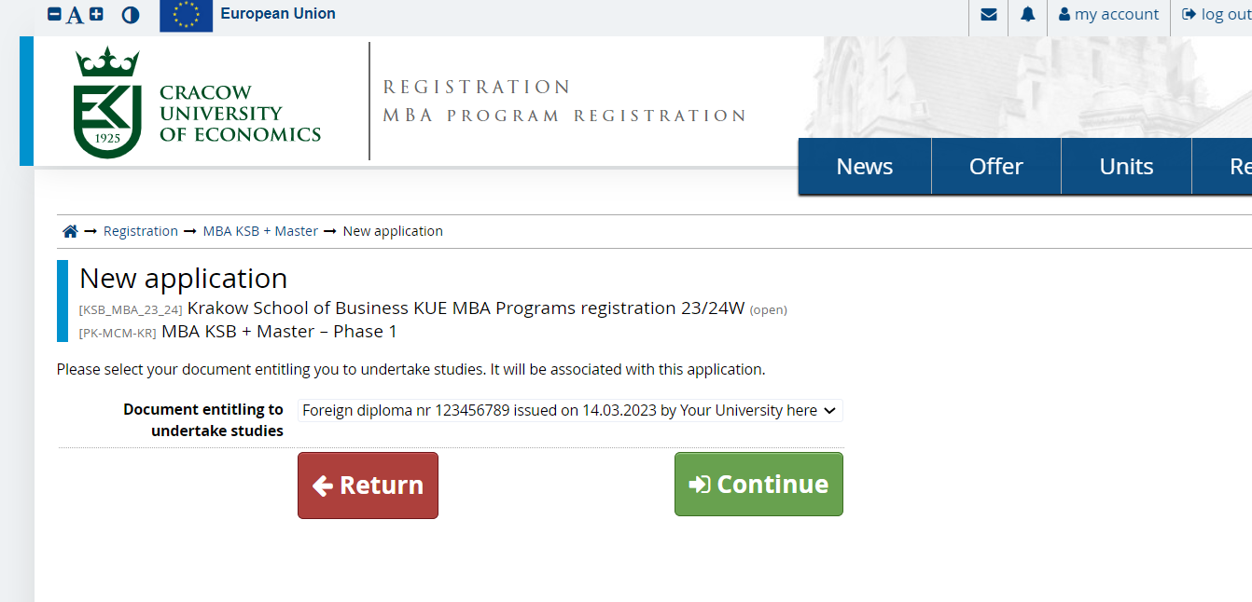
Submit additional Personal information.  Depending on the program the documents will vary.  Submitting your cover letter and current CV is required to submit your application. Fill out as many other questions and any other documents during this part of the process. You will be able to access them at a later time if your documents are not ready during the time of your registration.  After uploading your CV and Cover letter and submit your application in the bottom right corner. | 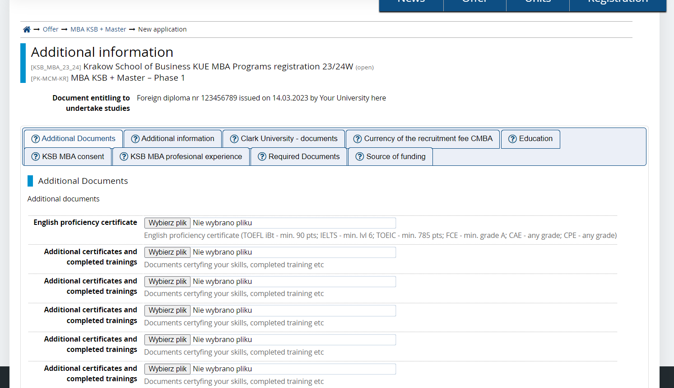
You have successfully registered for the MBA Program! | 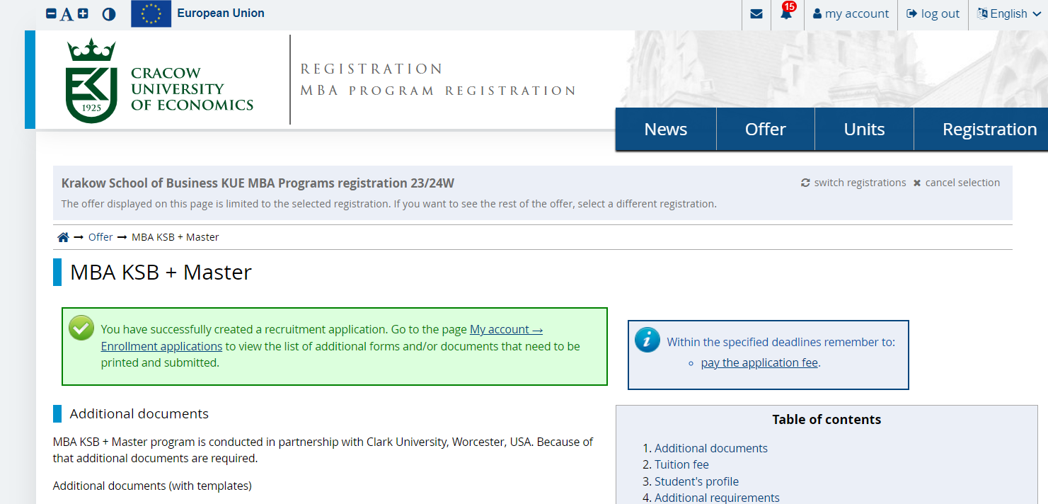
You must fill out the remaining information before the recruitment ends. You can access all the personal information sets in “my account”, “Enrollment applications” tab.

Paying the recruitment fee
After you register you will be required to pay the recruitment fee. The recruitment fee is different depending on the program chosen.

In the IRK system you will get notified with the following pop-up:
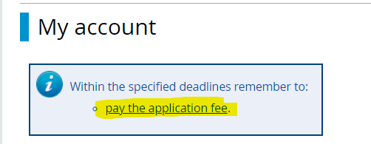

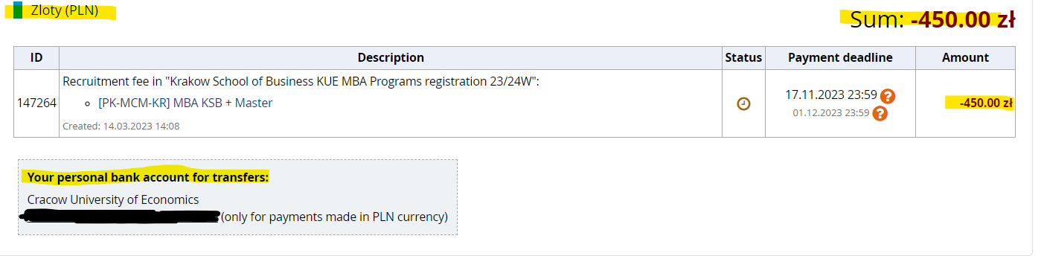

If you wish to pay the recruitment fee in EUR please contact the MBA office and DO NOT transfer EURO to your personal IRK bank account number.

If your recruitment fee is financed by a company you will need to fill out the Application form for the MBA studies and upload it into the IRK system (my account -> enrollment applications -> Source of funding).

The Program Manager/Program Coordinator will contact you.

If you have any questions regarding the registration process contact:
Łukasz Czyż, BA
MBA KSB + Master Program Coordinator.
+48 12 293 75 53
cmba@uek.krakow.pl

Or visit our website and go to the “Contact” tab:
https://ksb.uek.krakow.pl/en/contact/

